RoomUP Application Architecture Pattern

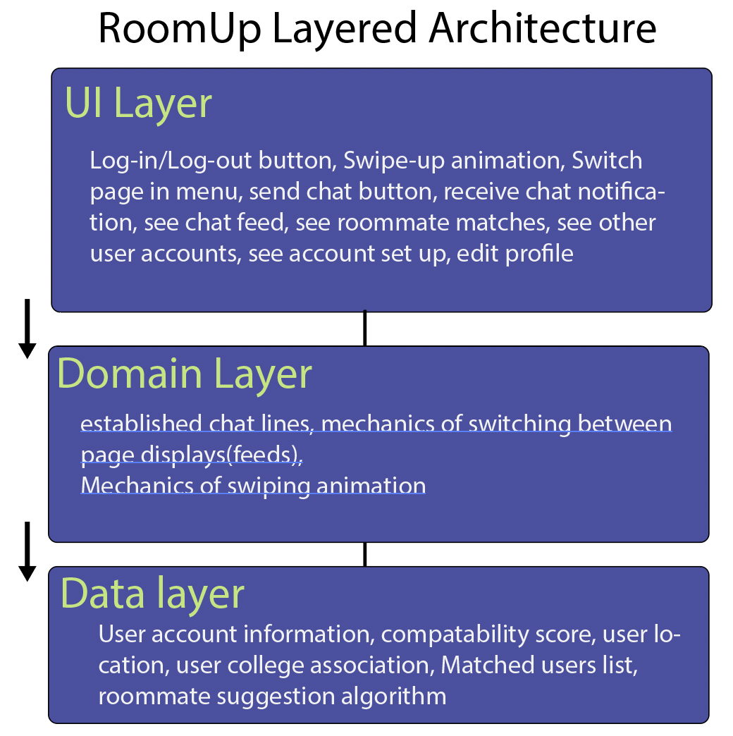

Design and Justification:

The RoomUP Android application is being built using the “Layered Architecture for Android Apps”. The UI Layer contains what the viewer will see, touch, and interact with, as well as most of what the user will associate with the app. Basic interfaces such as buttons, selecting text boxes, and inputting text are all aspects that the UI layer is responsible for. All these aspects of our app are grouped together as they involve either displaying information to the user or a user interaction, such as tapping or swiping.

The Domain Layer is the bridge between the UI Layer and the Data Layer. It contains frequent interactions between the two other layers so that these interactions can be simplified and expedited. Such routine interactions include sending and receiving chat messages, the recording of whether another user is swiped up on and swiped down on, and switching between pages.

The Data layer of an Android app contains the business logic of the application. Essentially, “it’s made of rules that determine how an app creates, stores, and changes data.” (Google Developers, 2023). For RoomUp, we will have different classes for user account information, user location, compatibility scores, matched user lists, and suggested roommate lists. Additionally, in this layer we will store the suggested roommate algorithm which will give users suggested roommates based on if they match with the user. We plan to use Firebase as our main database, which will house all this data within collections and documents.

We chose this pattern not only because RoomUP is being developed for Android, but also because it makes sense for the features and design of the app. Keeping the layers separate means that each can operate without knowledge of the interior working of the others; that is, one layer will view the others as abstracted, black boxes. It would be inconvenient, for example, to develop the storage and retrieval process for user data as dependent upon the process for the swipe up animation.

Additionally, the three-layer model matches well with the conceptual design of RoomUP. The app consists primarily of: user information such as location and lifestyle preferences; ways for the user to access this information; and the matching and chatting features. These three areas align rather well with the UI Layer, the Data Layer, and the Domain Layer, respectively. This Layered Architecture is a good fit for RoomUP.

Citations:

Google Developers. (2023, February 16). *Guide to app architecture : android developers*. Android Developers. Retrieved March 5, 2023, from https://developer.android.com/topic/architecture